**DETECTING PNEUMONIA IN A   
CHEST X-RAY USING DEEP LEARNING**

Khaled A. Alsheshtawi, PhD1  
Head of Artificial Intelligence Dept.  
College of Information Technology,  
 Jan Youssef2, Bishoy Samir3, Mohamed Osama4, Mohamed Tarek5

1Misr University for Science and Technology   
Email: khaled.alsheshtawi@must.edu.eg

2Misr University for Science and Technology  
Email: 89477@must.edu.eg

3Misr University for Science and Technology  
Email: 89534@must.edu.eg

4Misr University for Science and Technology  
Email: 89402@must.edu.eg

5Misr University for Science and Technology  
Email: 89610@must.edu.eg

**ABSTRACT**

Our motivation for this project is to address the global shortage of trained radiologists [1], specifically in Egypt, which faces a steep increase in healthcare prices and a decline in availability especially for low-income Egyptians. Our objective is to create an AI model which is capable of classifying Chest X-Rays into those positive for Pneumonia and those negative, with a higher focus on sensitivity or the *“true-positive rate”*, as recommended by the WHO [2], these guidelines were chosen because the highest chances of saving lives through detecting cases which are very likely to be positive. Our methodology consisted of dividing the data into 80% for training, 10% for testing, and 10% for validation, following that we tuned our model to give equal weights to each of the RGB channels in the image, as we found one channel tended to dominate the others. During the training, the model was instructed to learn much more heavily from the negative cases, as our data was comprised of 90% positive cases and 10% negative cases which was biasing the model towards the positive case. We found that our model achieved ~88% accuracy, compared with [3] which achieved 76.4% on the same dataset. This was accomplished with minimal training on the free tier provided by the Kaggle platform, further fine-tuning may be possible with better hardware.

**KEYWORDS:** Artificial Intelligence; Pneumonia; X-rays; Detection; Screening

**1.** **INTRODUCTION**

Is it possible to replace trained radiologists with trained AI models? Multiple previous studies have attempted to use AI for the detection of pneumonia in chest x-rays, [3] found that 50,000 people die from pneumonia annually. They developed a novel mechanism using feature extraction and dimensionality reduction, outperforming Mobile Net, Exception Net, and Resnet. Multiple deep learning architectures were used, with the proposed mechanism achieving the highest accuracy. Well-known architectures are unsuitable for pneumonia detection in low computational power environments. However, they were only able to reach an accuracy of 76.4%. While previous research attempted to tackle the problem of radiologist shortage using AI, their results were not strong enough to motivate decision makers, in this paper we believe our approach can be used in environments where computing resources are not abundant, thus making it perfect for developing countries and groups with access to incomplete data for training. Our paper argues that AI models must be used extensively by Egypt and other countries suffering from a shortage of medical professionals, to alleviate the pressure on low-income groups suffering from healthcare inaccessibility. It first establishes the functional and non-functional requirements for such a project, then goes on to discuss the scope and algorithms used, and finally the results and potential objections.

**2. METHODOLOGY**

2.1 Data loading and preprocessing: The dataset is loaded using a class from the torchvision library. Data transformations such as resizing images to a specific size and converting them to tensors are applied using the transforms module.  
2.2 The directory structure of the dataset is explored, which returns the class labels.   
2.3 Data loaders for the training and testing datasets are created using the DataLoader class. The dataset can be iterated over in batches, with the data shuffled and loaded in parallel. The datasets.ImageFolder class and the previously defined transformations are used to create the training and testing data loaders.  
2.4 The mean and standard deviation of the training dataset are calculated. These statistics are used to normalize the image data.  
2.5 We used Transfer Learning technique with ResNet18 model as the base model, and a new fully connected layer is substituted to adapt it to the binary classification task. The model parameters are optimized using the Adam optimizer, and a learning rate scheduler is used to adjust the learning rate during training. The binary cross-entropy loss function is defined using nn.BCEWithLogitsLoss.  
2.6 A weight tensor is created based on based on quantity of each class in the training dataset. This tensor is utilized to assign higher weights to minority class samples during training.   
2.7 The model is trained using a loop that iterates over the training dataset. In each iteration, the model parameters are updated using backpropagation and the calculated gradients. The model weights are adjusted based on the computed loss value. The learning rate scheduler is also updated according to the validation loss.  
2.8 The test dataset is evaluated by iterating over the test data loader. Predictions are generated using the trained model, and the performance metrics are calculated.

**3. RESULT  
3.1 Training vs Testing Accuracy**  
Our model achieved a commendable accuracy rate of 88%, showcasing its robust performance and proficiency in the task at hand.

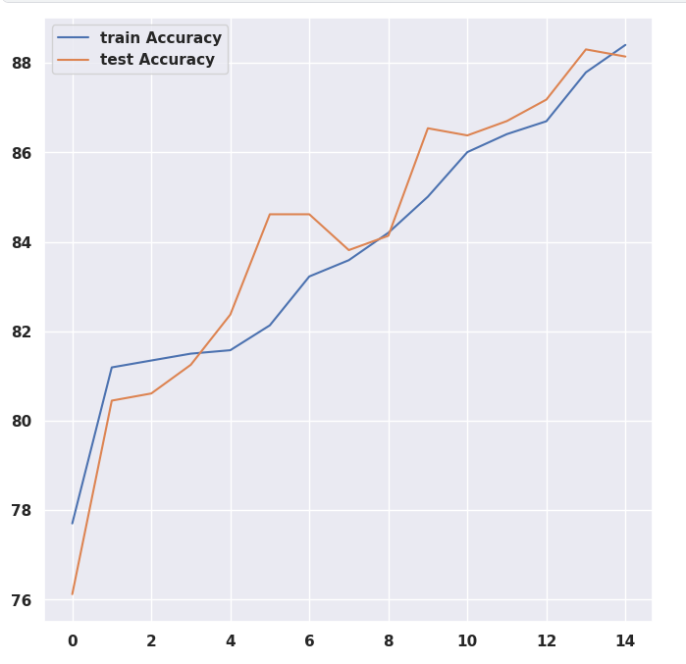

Figure 1. Train vs Test Accuracy.

**3.2 Predicted Vs Actual Value for A Sample of X-rays** 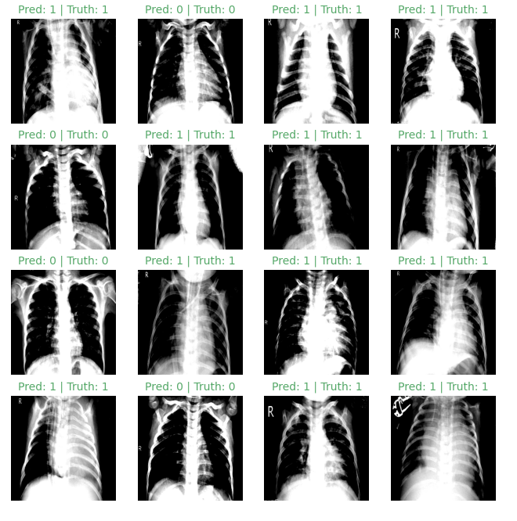

Figure 2. a 4x4 plot of predicted and actual value for a sample of CXRs.

**3.3 The Response From Our API When a CXR is Uploaded**

Figure 3. The response from our API

**3.4 A Comparison of Algorithms Used and Accuracy**

Table 1. A Comparison of Algorithms Used and Accuracy

|  |  |  |  |  |
| --- | --- | --- | --- | --- |
| Study | Published on | Dataset | Algorithms used | Accuracy |
| Hayelny | 2022-23 | 5,863 Chest X-ray images | Channel-wise normalization  Weighted loss function  Weight decay  Learning scheduler  Data Augmentation  CNN Architecture:  Resnet18 | 88% |
| [4] | December 2020 | Montgomery dataset (138 images) Shenzhen dataset (662 images) | Canny Algorithm [13] | 93.59% |
| [5] | July 2021 | 3000 images for normal chest X-rays were selected from different public image databases.  623 chest X-ray COVID-19 images were collected from the GitHub repository, expanded to 2000 by image augmentation | VGG16 [14]  ResNet50 [15]  InceptionV3[16]  Transfer learning [17] | >98% |
| [6] | May 2021 | 550,297 images | Mask RCNN28 with a ResNet-101-FPN.  Single Shot MultiBox Detector  EfficientNet-B7 with  an attention pooling layer and a fully-connected layer. | Sensitivity: 88%  Specificity: 79% |
| [3] | 2021 | 5,863 Chest X-ray images | SIFT Feature  Scale-space extreme value detection  Construct scale space  Keypoint positioning and feature description.  Vector normalization to generate descriptors.  Feature clustering algorithm:  - K-means ++  - Bag of Visual Words  - Support Vector Machine  - K-Nearest Neighbor  - Naive Bayes  - Random Forest  Deep Neural Networks:  - VGGNet  - GoogleNet  - ResNet  - DenseNet  - Inception  - MobileNet  - Xception | 76.4% |
| [7] | Jan 2021 | 6749 two-view chest radiographs | Resnet18 pre-trained with ImageNet CNN | 74% |

**4. DISCUSSION**

We Managed to achieve an accuracy of 88% despite a bias in the dataset, this places us firmly as the top performing study published which used the same dataset, for example, [3] only managed to reach 76.4%, despite their complex model architecture and resources. Criticisms to our work are the limited nature of our model, due to the limited size, and the bias in the dataset, coupled with the limitations which face any AI model when moving from the lab to the real world. Our model bundles together all types of pneumonia under one label for the purposes of simplification, this subtracts from its real-life value.

**5. CONCLUSION**

In conclusion, we find that AI provides a strong opportunity for use in low-income countries as an alternative to trained medical personnel, not ignoring the inherent limitations of our model and all AI models in general such as the trust problem and ethical considerations. Lastly we recommend that more work and resources be allocated to this type of research, and future research to attempt to tack the limitations found in this paper.

**ACKNOWLEDGMENT**

We would like to express our deepest gratitude and appreciation to our supervisor Dr Khaled A. Alsheshtawi, PhD, for his invaluable guidance, support, and mentorship throughout the course of this study. His expertise, encouragement, and insightful feedback have been instrumental in shaping this research project. We would also like to extend our sincere thanks to the faculty members of Computer and Artificial Intelligence Technology faculty for their contribution to our academic journey. Their dedication to excellence in teaching and research has provided me with a solid foundation of knowledge and skills. We are indebted to the staff and resources of Computer and Artificial Intelligence Technology for their assistance and cooperation during the course of our entire project. Their professional support has been instrumental in the successful completion of this study.

**6. REFRENCES**

[1] “Radiology Facing a Global Shortage.” https://www.rsna.org/news/2022/may/Global-Radiologist-Shortage (accessed Nov. 09, 2022).

[2] “WHO consolidated guidelines on tuberculosis: module 2: screening: systematic screening for tuberculosis disease.” https://www.who.int/publications-detail-redirect/9789240022676 (accessed Nov. 09, 2022).

[3] Z. Meng, L. Meng, and H. Tomiyama, “Pneumonia Diagnosis on Chest X-Rays with Machine Learning,” *Procedia Comput. Sci.*, vol. 187, pp. 42–51, Jan. 2021, doi: 10.1016/j.procs.2021.04.032.

[4] S. Hwa, A. Bade, M. Hijazi, and M. Jeffree, “Tuberculosis detection using deep learning and contrastenhanced canny edge detected X-Ray images,” *IAES Int. J. Artif. Intell. IJ-AI*, vol. 9, p. 713, Dec. 2020, doi: 10.11591/ijai.v9.i4.pp713-720.

[5] S. Guefrechi, M. B. Jabra, A. Ammar, A. Koubaa, and H. Hamam, “Deep learning based detection of COVID-19 from chest X-ray images,” *Multimed. Tools Appl.*, vol. 80, no. 21–23, pp. 31803–31820, 2021, doi: 10.1007/s11042-021-11192-5.

[6] S. Kazemzadeh *et al.*, “Deep Learning Detection of Active Pulmonary Tuberculosis at Chest Radiography Matched the Clinical Performance of Radiologists,” *Radiology*, p. 212213, Sep. 2022, doi: 10.1148/radiol.212213.

[7] J. D. Schroeder *et al.*, “Prediction of Obstructive Lung Disease from Chest Radiographs via Deep Learning Trained on Pulmonary Function Data,” *Int. J. Chron. Obstruct. Pulmon. Dis.*, vol. 15, p. 3455, 2020, doi: 10.2147/COPD.S279850.